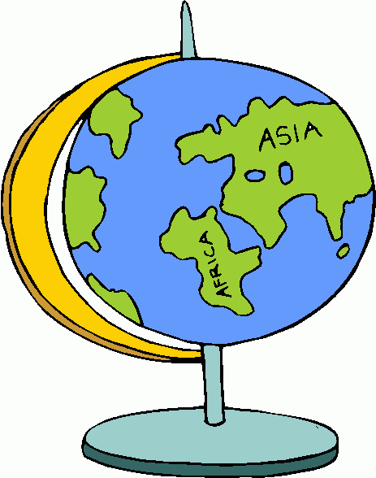
AROUND THE WORLD PROJECT – Middle East

Various Middle Eastern countries have hired you to create presentations in an effort to promote tourism. These presentations must include in-depth information about the country’s culture as well as travel guidelines and restrictions for those interested in visiting.

Task: Create an informational slideshow for the country of your choice.

Objectives:
- Research the country of your choice using books, databases, and websites.
- Find the following:
  - Basic demographics and cultural information – location, population, language, currency, religion, weather, etc.
  - Economic System- What type of system does your country have and what does that mean? What businesses or products is your country known for?
  - Political System- What type of system does your country have and what does that mean? How free is the nation? Think speech, press, etc.
  - Current events that are important to the political/social climate of the country – What does this mean for travelers? Riots? Protests?
  - Historic and Cultural Relevance – important historical places to visit, important festivals, and local cuisine. Think what a visitor would be interested in/need to know.
  - Travel restrictions – Warnings, bans on travel, danger, vaccinations required, etc.
- For those working on their own, use the guidelines in #2 with the following amendments
  - Only 1 current event and 1 place of interest is required. Information on festivals and cultural faux pas are not required
  - See rubric for more details
- For those working in Groups of 3, use the guidelines in #2 IN ADDITION TO
  - History Section- overview of key figures/events and how these shaped the nation
  - See rubric for more details
- Create Google Slideshow to communicate your findings. Make sure your information is clear and structured
- Images- various attractions, landscapes, people, etc. throughout your slideshow. It needs to look appealing
- Works Cited- create a separate slide; cite things correctly
Resources: Can be found on the PTHS Library’s website.

Helpful Tips:
Outline: Create an outline that’ll help organize your website. List all of your findings under each section.
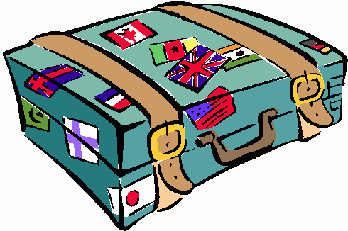
Google Doc: If you’re collaborating with another person or group of people, create a Google Doc that will allow you to share information, edit your findings, etc.

Your work will be assessed according to the rubric provided to you by Miss Corsinelli and available electronically on our website. Refer to the rubric as often as you need to while completing your website.

Suggested Timeline-
Day 1 (in class)- Identify resources to use and divide the work between you and your partner (if applicable). Create slideshow, Google Doc (if needed) and add the name/description of your travel company
Day 2 (in class)- Begin to research. Cite information correctly. Put things in YOUR OWN WORDS!
Day 3 (in class)- Add your information to the slideshow and locate/cite info for any other section you are responsible for. At least 2 sections should be completed.

Day 4 (in class)- Continue research and adding information. Project/your sections should be mostly finished.

Day 5- Add any remaining information to your slideshow, including pictures (make sure they display
correctly!) and your Works Cited.

By the weekend you should be done. Proofread your section!

I will NOT be checking your Google doc so anything you want graded should be in the slideshow!

